# Exercise: Passing Data from Page to Page

There are several strategies for passing and persisting data amongst the various Content Pages of your application. This exercise will explore two fairly simple approaches. A database (covered later) is also well suited to this task.

## Passing Simple Data to a New Page

Create a page that has three buttons: Joe, Jane, and Jenny

Clicking on a button will open a new modal page that identifies the button clicked on. Create a constructor for this new page class that takes in a string. The string can then be used by the page to display the correct person’s name. There should also be a button to close the modal page.

## Pass By Reference

Passing an object to another page allows modification of that object in memory. If this object is then used on the original page, the changes will be persistent. This is also sometimes referred to as passing the model.

* Create a Person class with first name and last name
* Add an array of Person objects to the first page with the first names corresponding to the buttons.
* Add a constructor to the second page that takes in a Person object and changes the last name property of it to “Changed”. It will then do the same thing as the other constructor.
* Add three new buttons that will call the new constructor and pass in the appropriate Person
* Add a button at the end that will change the Text of each button to also show the associated last name.

Obviously this example does something bizarre, but the point is that you can pass around your data/model (pass by reference) and make changes which can affect multiple pages.

## Finished Interface

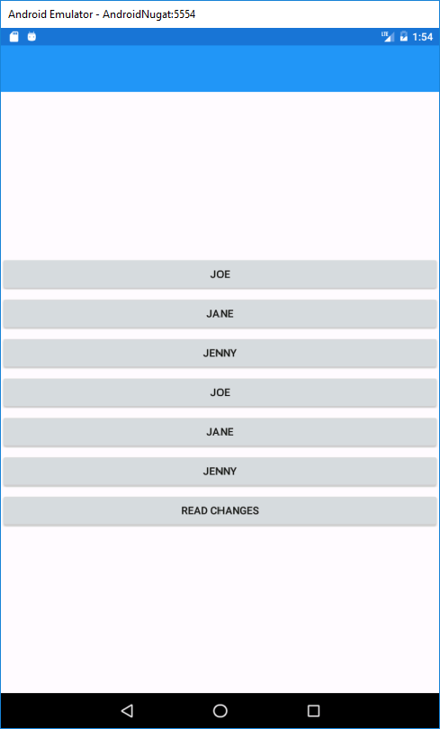 After Clicking Jane 2, then Read Changes: 